Planar graph

如果g可以在一个平面被画出来，并且他们的所有edge只在vetice处交叉，那么这个graph就叫做plane graph

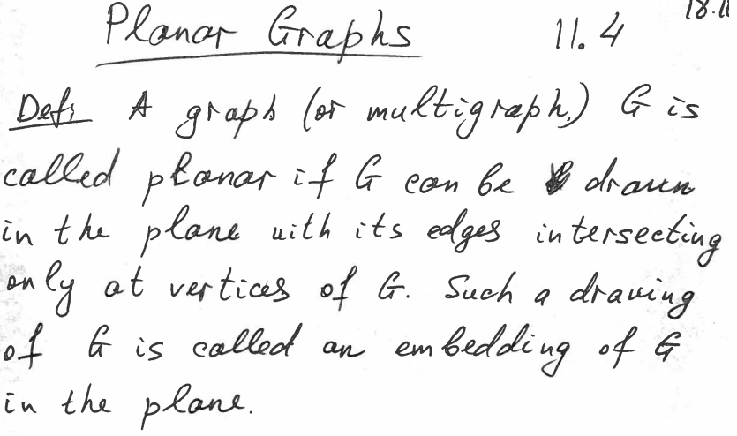

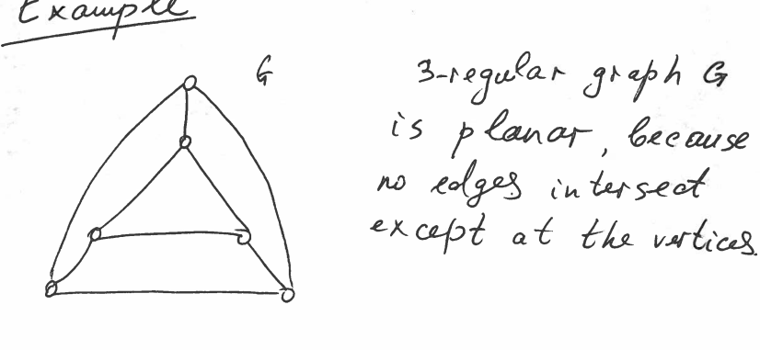

这个就是planar

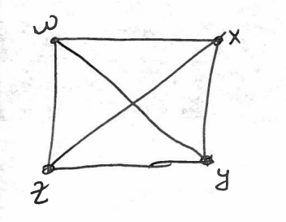

这个不是planar因为wy 与xz不在端点处交叉

但是我们可以重新画他让他交叉

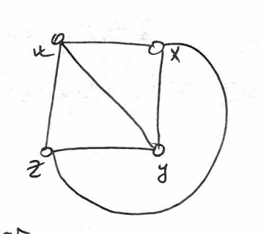

但是K5做不到planar(5个端点，每对端点都有Path)

首先必然有基础

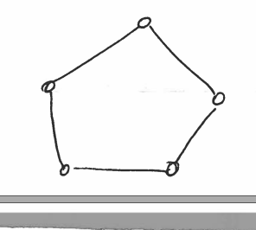

里面的区域至多画两个edge

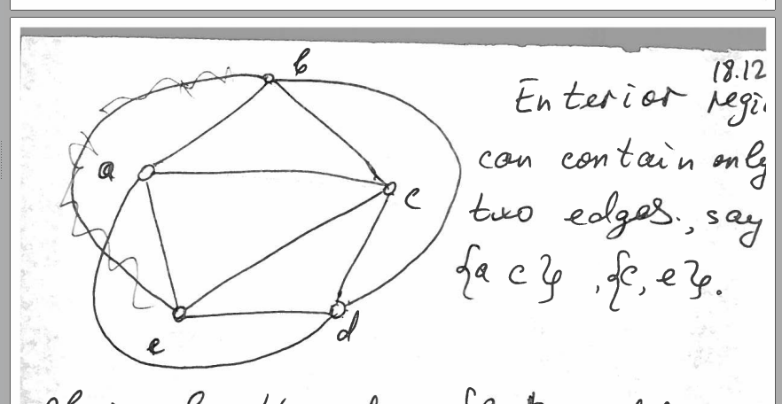

那么ad bd必在五边形外面，我们同时有需要BE，被挡住了所以不是planar

一个graph 叫做bipartite 当且仅当你可以吧V分成两部分，V1UV2=V,V1V2没共同点，然后每条edge都能表示成{a,b}形式，a∈v1,b∈v2,.

Complete bipartite graph：当且仅当V1中每一个点都和V2中每一个点有edge，如果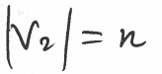，complete bipartite graph记做K m,n

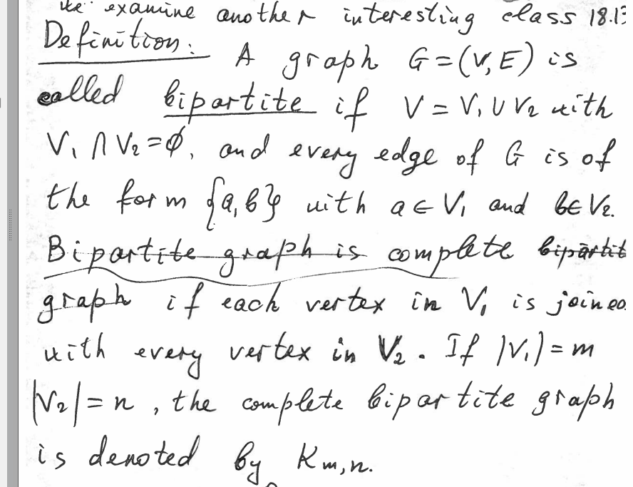

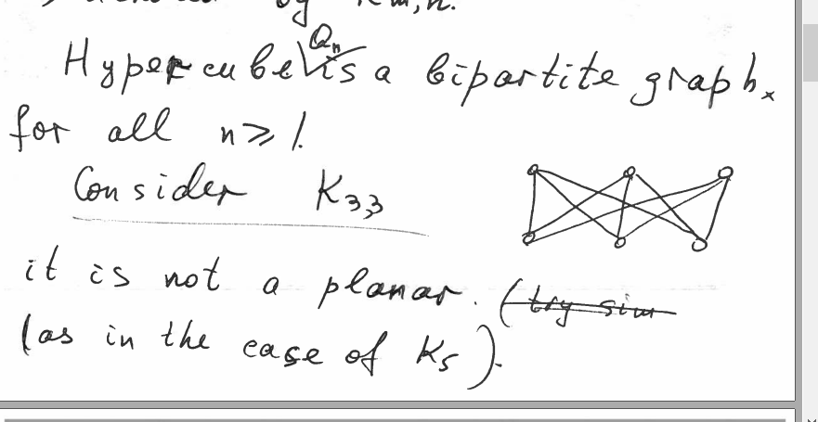

（上面的三个点是M点）

任意一个hypercube都是bipartite graph（因为完全复制连上，也就是相当于V1就是原有点，V2就是复制点）

K33不是planar

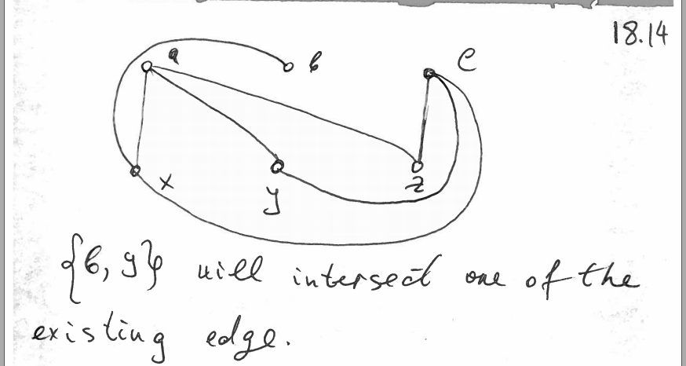

by 必然会和现有edge相交

如果G=VE是一个loop free undirected graph，那么elementary subdivision of G 就是

一个edge e={u,w}被移除，然后换成两条edge{u，v}，{v,w} 同时v不属于原有vertices

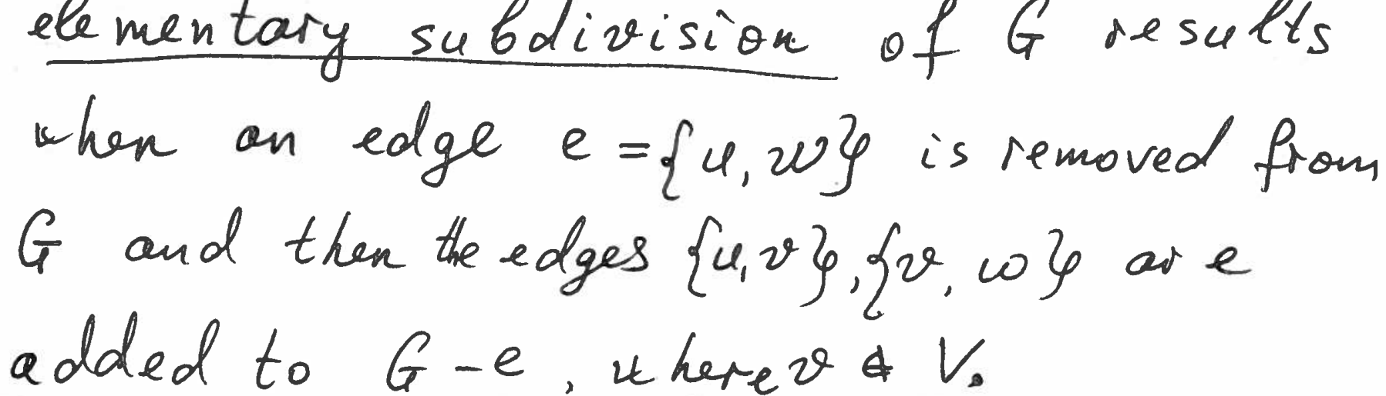

Homomorphic齐次： 两个graph可以被称作homomorphic如果他们是isomorphic的或者他们都可以从同一个graph H通过一系列的elementary subdivisions得到

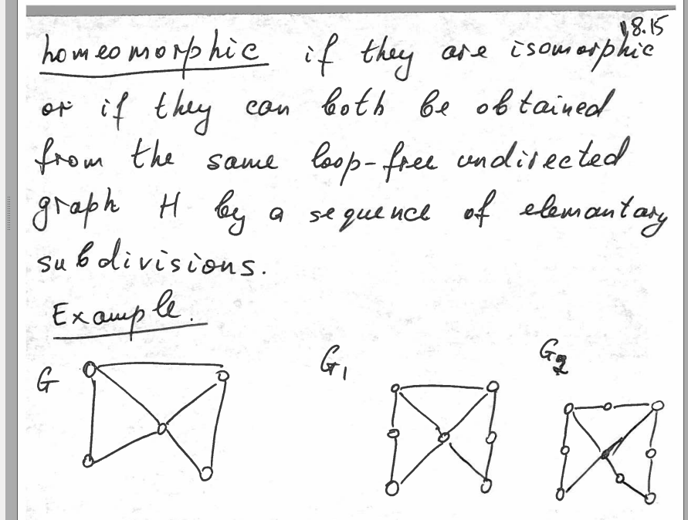

如果由两个graph是homomorphic的，那么他们都planar或者都不planar

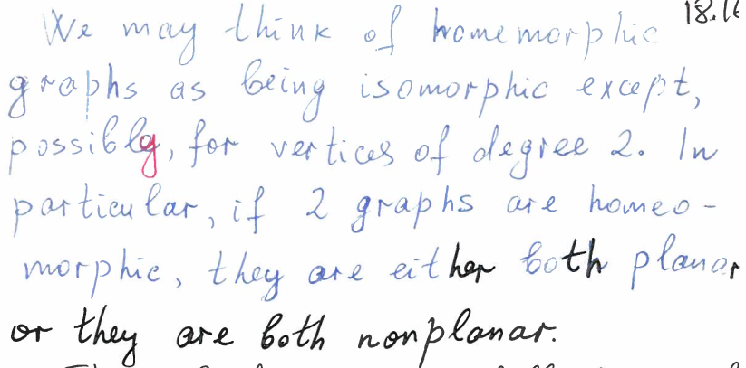

推出结论

Kuratouskis theorem，

一个non planar的graph，那么他必然包含一个subgraph与K5或者K3，3是homographic关系

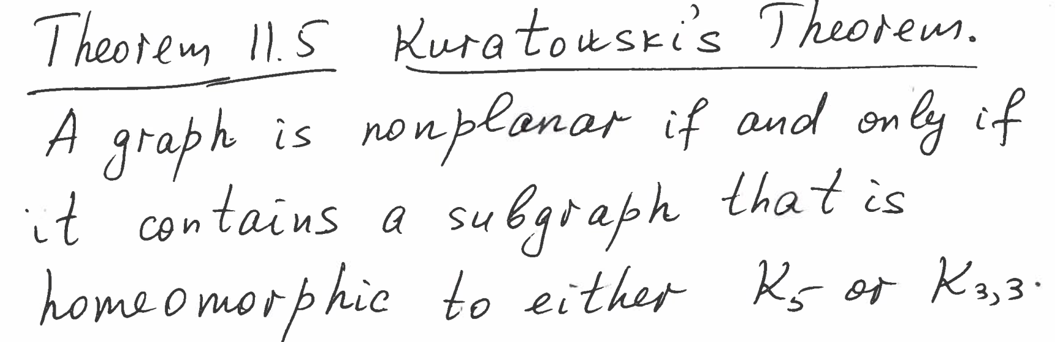

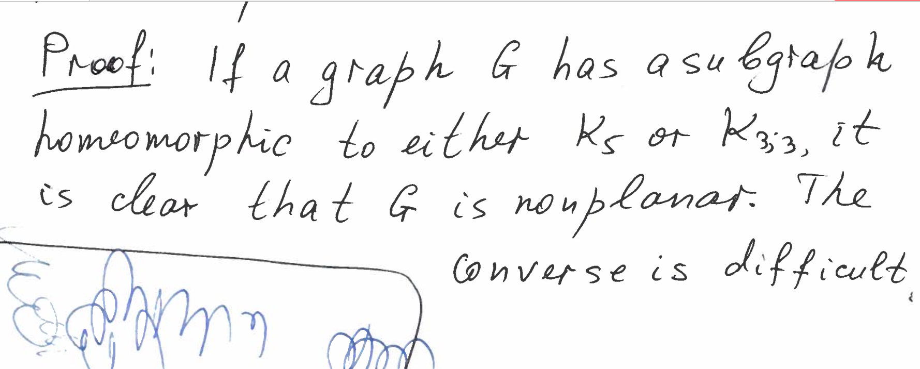

证明方法：如果G有一个k5的homomorphic，那么他肯定是nonplanar

1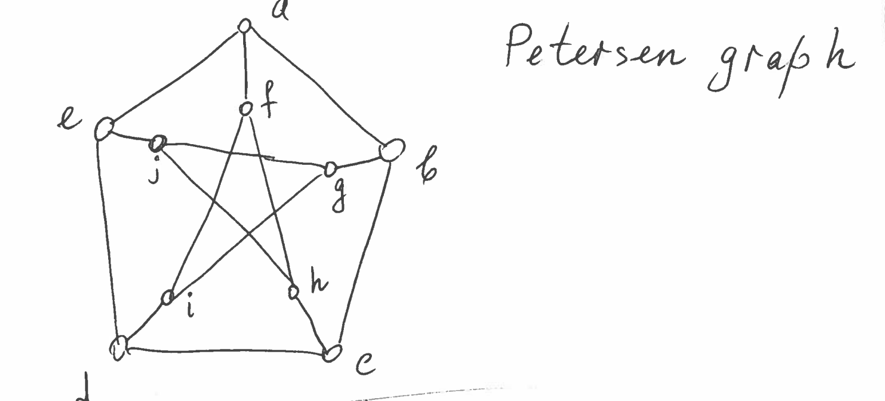

Petersen graph

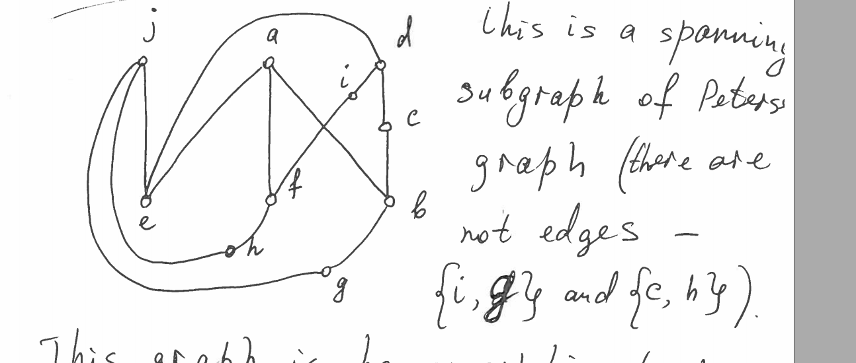

这是petersen graph的spanning subraph,少了 ig 与ch edge, 这个graph与k33齐次，因此peterson是nonplanar的

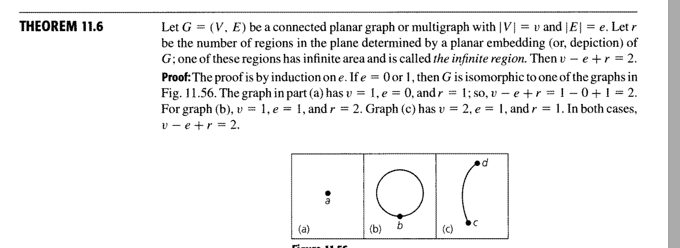

如果一个planar graph， r代表着有限region和无限region，那么v-e+r=2

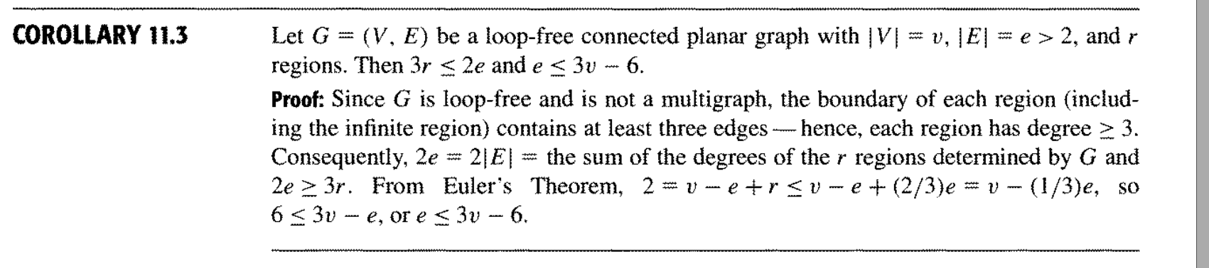

如果graph想planar,那么region(面积部分)\*3<=2edge, edge<=3v-6

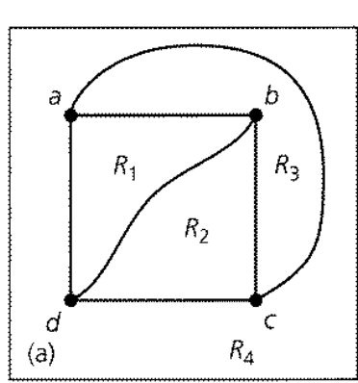

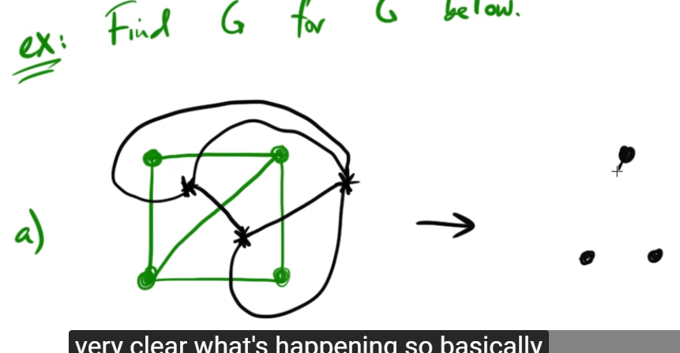

dual graph, 找到代表着region的点，连接所有可能的线，只要这个线穿过一个edge，形成dual graph

11.4 例题

Problem 6

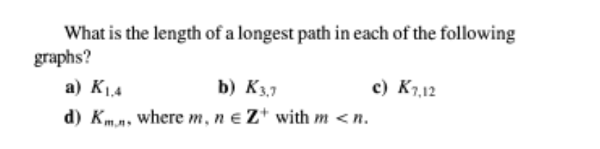

11.4

For this question, I will divide vertices into top part {top1,top2,top3} and bottom part {bot1,bo2,bot3 } like k3,3

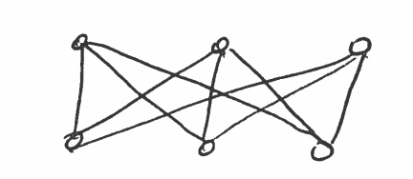

a/ 2 , bot1->top1->bot2

b/ the path will be bot1->top1->bot2->top2->bot3…..

and we can divide the path by top point, then the path will be bot1<-top1->bot2 ,

bot2<-top2->bot3…the length of path will equal 2\* the number of top(or bot if the number of bot vertices is smaller) , The answer is 2\*3=6

c/ 2\*7=14

d/2\*m

PROBLEM 7

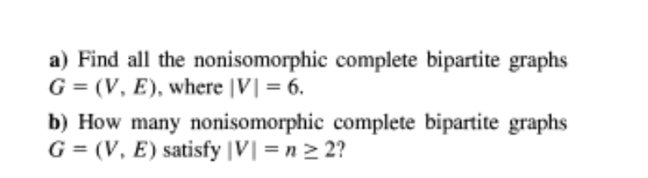

A/K15 K24 K33

B/

If n is even, it will be K(1,n-1) K(2,n-2),…………..k(n/2,n/2) So there are n/2 graphs

If n is odd, it will be K(1,n-1) ………….K((n-1)/2) so there are (n-1)/2 graphs

PROBLEM 8

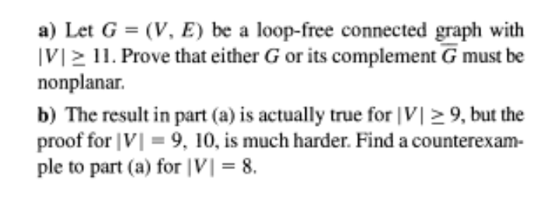

a/assume V=11, the edge of G is E1, edge of is E2, then if they are both planar, then E1<=3v-6 ,E2<=3V-6 , E1<= 27 ,E2<=27, . And K11 edge will be nC2= 11C2=55 >=e1+e2, so it is impossible, so one of them must be nonplanar

b/ E1 E2<=18, 8C2=28, possible

G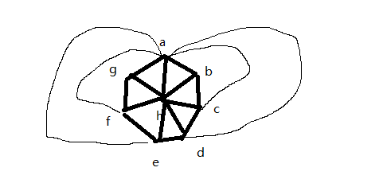edge =18 max

Point A is complete, H is compelete,

B need bd be bf bg

C need CE CF CG

D need df dg

E need eg

edge =10 , perfect

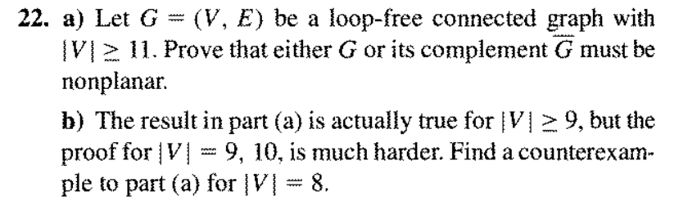

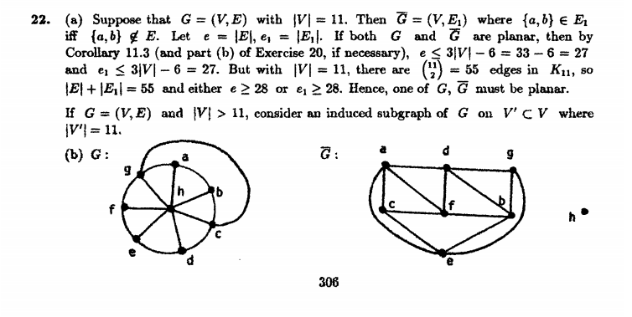

PROBLEM 9

No

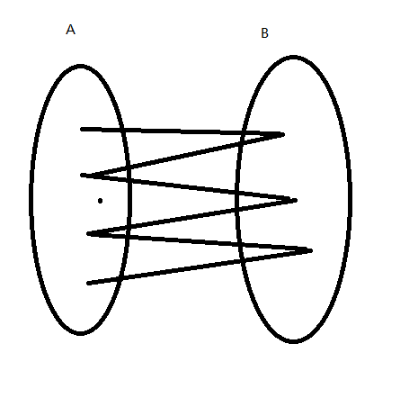

if we start from vertice set A , it must be one a->b and one b->a loop to come back to setA

if we want to build a loop, it must start from A(B), end at A(B), which means that the loop will be made up of these come-back loops which are 2-edge-long(even)





PROBLEM 10

cause its dual graph is isomorphic to G, then they have same |V|, and |V| of dual graph = r of G, so |V|-|E|+r=2

2|V|-|E|=2

|E|=2n-2



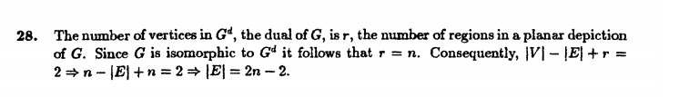

PROBLEM 12

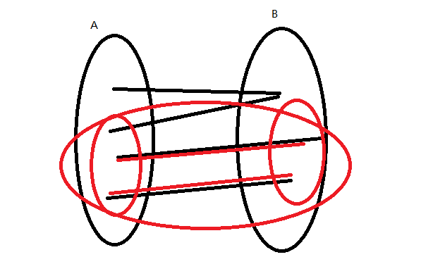

Let the vertices of orginal graph G be devided into set A and set B , pick random vertices from G to build subgraph S, and we can find every vertex in subgraph is a member of A or B, so we can divided the vertices of S into set C and set D , and C D is subset of A and B, and the old {A,B} edge will also be {C,D} edge in subgraph, so S is still bipartite



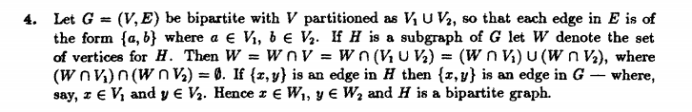

PROBLEM 13

QUESTION 18



each region has at least five edges, which means the degree of each region >=5,

5\*53<=The sum of degree= 2|E|

|E|>=132.5 , |E|>=133

|V|-|E|+r=2

|v|=|E|-51>=82

11.7

PROBLEM14

11.7

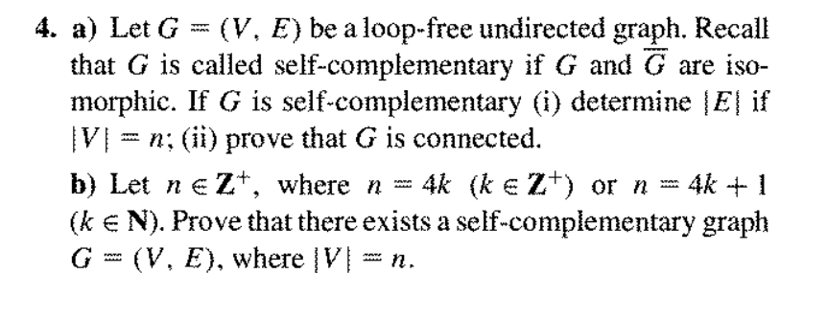

a/

1/so there are 2n vertices in a complete graph, then each vertice has 2n-1 degree, there are 2n\*(2n-1)/2 =n(2n-1)edges in complete graph(divide 2 because repetition), and edge of G and are equal, so |E|=n(2n-1)/2

2/if G is not connected ,then will be connected because it is undirected graph, and cause they are isomorphic ,so if is connected ,G will be connected

b/when k=1, n=4,

G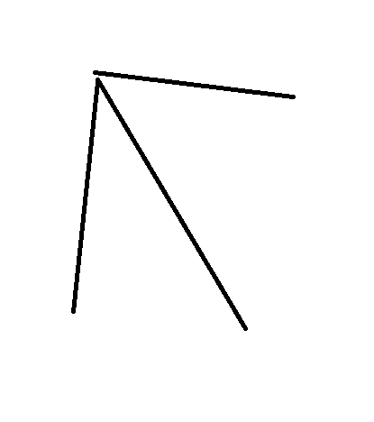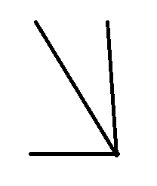

There exists one example ,true.